**ASSIGNMENT-6**

**GREP**

1. Use any .c file. Using grep command extract and display

a. all lines beginning with #include with line numbers

A: grep -n "^#include" example.c



b. display all lines which do not begin with #include

A: grep -v -n "^#include" example.c

c. display the line number of main()

A: grep -n "main()" example.c

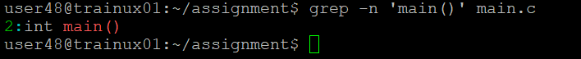

d. extract all lines containing characters of opening and closing parathesis {(,))

A: grep -n "[()]" example.c

2. Perform the above operations on a set of *.c files

A:

1. grep -v ‘^#include’ *.c

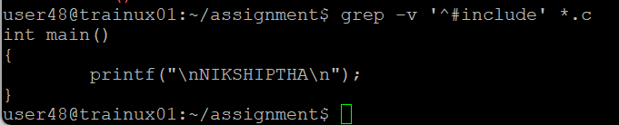

b. grep -n "^main()" *.c

c . grep -n "[()]" *.c

